The ideal oyster for a sustainable Pacific oyster aquaculture

Ernest Obeng Chuku, Steven Rust, Andrew Trotter, Gregory Smith, Debashish Mazumder

**Supplementary Data**

***Supplementary Table 1*:** Results of Fleiss’s kappa analysis of concordance results for the individual traits assessed.

|  |  |  |  |
| --- | --- | --- | --- |
| Pacific oyster trait | Kappa | z | *P*-value |
| **Production traits** |  |  |  |
| Disease resistance | -0.200 | -0.490 | 0.624000 |
| Fast growth | 1.000 | 2.449 | 0.014000 |
| High survival | 1.000 | 2.449 | 0.014000 |
| Robustness in handling | 1.000 | 2.449 | 0.014000 |
| Tolerance for wide temperature variations | 1.000 | 2.449 | 0.014000 |
| Uniform growth | -0.200 | -0.490 | 0.624000 |
| **General market-related traits** |  |  |  |
| Brittleness | -0.077 | -0.499 | 0.618000 |
| Colour (meat or shell) | -0.077 | -0.499 | 0.618000 |
| Condition index | -0.077 | -0.499 | 0.618000 |
| Consistency of size | -0.077 | -0.499 | 0.618000 |
| Cup depth | 0.282 | 1.828 | 0.068000 |
| Shell hardness | -0.077 | -0.499 | 0.618000 |
| Meat condition | 0.282 | 1.828 | 0.068000 |
| Meat size | -0.077 | -0.499 | 0.618000 |
| Roundness | -0.077 | -0.499 | 0.618000 |
| Smell | -0.077 | -0.499 | 0.618000 |
| Taste | -0.077 | -0.499 | 0.618000 |
| Tenderness | 0.282 | 1.828 | 0.068000 |
| Texture | 0.282 | 1.828 | 0.068000 |
| Uniformity of shape | -0.077 | -0.499 | 0.618000 |
| **Ideal shell shape** |  |  |  |
| A | 0.111 | 0.385 | 0.700000 |
| B | 0.111 | 0.385 | 0.700000 |
| C | -0.333 | -1.155 | 0.248000 |
| D | 1.000 | 3.464 | 0.001000 |
| **Premium shell colour** |  |  |  |
| Dark | 0.111 | 0.385 | 0.700000 |
| Golden | 0.111 | 0.385 | 0.700000 |
| Light | 0.111 | 0.385 | 0.700000 |
| Stripe | 0.111 | 0.385 | 0.700000 |

***Supplementary Table 2*:** Definition of the variables used for the proportional odds logit models

| **Variable** | **Variable definition** |
| --- | --- |
| Sate | Australian territorial state of the respondent’s business location (as postcode) |
| SA | The respondent’s business location is South Australia (i.e., postcode 5000-5999) |
| TAS | The respondent’s business location is Tasmania (i.e., postcode 7000-7999) |
| SCseg | The supply chain segment of involvement in the Australian Pacific oyster industry |
| P | The respondent is a producer only |
| T | The respondent is a trader only |
| PT | The respondent is both a producer and a trader |
| **Production traits of the Pacific oyster** | |
| PdtraitRANK | Ordinal response outcomes (ranking) for production-related traits of the Pacific oyster in order of importance (1st = most important, …, 6th = least important) |
| Pdtrait | The specified production-related traits of the Pacific oyster for ranking |
| DR | Disease resistance (to POMS, SAMS, etc.) |
| FG | Fast growth |
| HS | High survival |
| RH | Robustness in handling/processing |
| TT | High tolerance to temperature variations |
| UG | Uniform growth |
| **Market traits of the Pacific oyster** | |
| MktraitAGREE | Ordinal response outcomes (agreeance) for market-related traits of the Pacific oyster in the order, strongly disagree, disagree, not sure, agree, and strongly agree |
| Mktrait | The specified market traits of the Pacific oyster |
| BRIT | Brittleness/chalkiness |
| COL | Colour of the meat or shell |
| CI | Condition index |
| CUP | Cup depth |
| HARD | Shell hardness |
| MEATC | Meat condition |
| MSIZE | Meat size |
| ROUND | Roundness |
| SIZE | Size |
| SMELL | Smell |
| TASTE | Taste |
| TEND | Tenderness |
| TEXT | Texture |
| USHP | Uniform shape |
| **Ideal shape of the Pacific oyster** | |
| ShpRANK‡ | Ranking for shell shape in order of preference (1st = ideal shell shape, …, 4th least preferred shell shape) |
| Shp | The specified shapes |
| ShpA | Shell height (H): Shell length (L) ratio if H = 2: 1.5 < L ≤ 2 |
| ShpB | Shell height (H): Shell length (L) ratio if H = 2: L ≅ 1.5 |
| ShpC | Shell height (H): Shell length (L) ratio if H = 2: 1 < L < 1.5 |
| ShpD | Shell height (H): Shell length (L) ratio if H = 2: L ≅1 |
| **Shell colour for premium price** | |
| ColRANK | Ranking of shell colour for premium price (1st = best price, …, 4th = least price) |
| Col | The specified colours |
| DARK | Darker/purple |
| LIGHT | Lighter/white |
| GOLD | Golden |
| STRIP | Striped (dark/white) |

***Supplementary Table 3*:** Brant-Wald test of the proportional odds assumption estimated on single-term model parameters for the proportional odds logit models. Probability values of $α≥0.05$ imply that the parallel regression or proportionality assumption holds.

|  |  |  |  |
| --- | --- | --- | --- |
| Test for | X2 | df | probability |
| *Production traits* |  |  |  |
| Omnibus | 54.52 | 24 | 0 |
| PdtraitFG | 4.29 | 4 | 0.37 |
| PdtraitHS | 10.64 | 4 | 0.03 |
| PdtraitRH | 13.22 | 4 | 0.01 |
| PdtraitTT | 4.27 | 4 | 0.37 |
| PdtraitUG | 5.38 | 4 | 0.25 |
| StateTAS | 0 | 4 | 1 |
| *Market related traits* |  |  |  |
| Omnibus | 174.59 | 45 | 0 |
| MktraitCI | 2.7 | 3 | 0.44 |
| MktraitCOL | 0.46 | 3 | 0.93 |
| MktraitCUP | 0.19 | 3 | 0.98 |
| MktraitHARD | 0.13 | 3 | 0.99 |
| MktraitMCON | 16.56 | 3 | 0 |
| MktraitMSIZE | 3.51 | 3 | 0.32 |
| MktraitROUND | 1.59 | 3 | 0.66 |
| MktraitSIZE | 0 | 3 | 1 |
| MktraitSMELL | 3.44 | 3 | 0.33 |
| MktraitTASTE | 5.27 | 3 | 0.15 |
| MktraitTEND | 7.17 | 3 | 0.07 |
| MktraitTEXT | 4.02 | 3 | 0.26 |
| MktraitUSHP | 0.74 | 3 | 0.86 |
| SCsegPRODTRAD | 9.04 | 3 | 0.03 |
| SCsegTRAD | 11.06 | 3 | 0.01 |
| *Shell colour* |  |  |  |
| Omnibus | 19.01 | 10 | 0.04 |
| ColGOLD | 4.75 | 2 | 0.09 |
| ColLIGHT | 0.03 | 2 | 0.99 |
| ColSTRIP | 2.61 | 2 | 0.27 |
| SCsegPRODTRAD | 0 | 2 | 1 |
| SCsegTRAD | 0 | 2 | 1 |
| *Shell shape* |  |  |  |
| Omnibus | 4.49 | 10 | 0.92 |
| ShpB | 2.83 | 2 | 0.24 |
| ShpC | 0.7 | 2 | 0.7 |
| ShpD | 0.77 | 2 | 0.68 |
| SCsegPRODTRAD | 0 | 2 | 1 |
| SCsegTRAD | 0 | 2 | 1 |

***Supplementary Table 4*:** Likelihood ratios tests of ordinal regression models used for model selection in a restricted modelling procedure. The models with interaction terms were selected at the 10% confidence level (P < 0.1)

|  |  |  |  |  |  |  |  |  |  |  |  |  |  |  |  |
| --- | --- | --- | --- | --- | --- | --- | --- | --- | --- | --- | --- | --- | --- | --- | --- |
|  | | Model | Resid. df | | Resid. Dev | | Test | | Df | | LR stat. | | Pr(Chi) | | Sig.† |
| *Response = PdtraitRANK* | | | | | | | | | | | | | | | | |
| 1 | | Pdtrait | 116 | | 379.4 | |  | |  | |  | |  | |  |
| 2 | | Pdtrait + State | 115 | | 379.4 | | 1 vs 2 | | 1 | | 0.00043 | | 0.983540 | |  |
| 3 | | Pdtrait + State + Pdtrait × State | 110 | | 368.4 | | 2 vs 3 | | 5 | | 11.00000 | | 0.051370 | | . |
| *Response = MktraitAGREE* | | | | | | | | | | | | | | | | |
| 1 | Mktrait | | 459 | 1122 | |  | |  | |  | |  | |  | |
| 2 | Mktrait + SCseg | | 457 | 1118 | | 1 vs 2 | | 2 | | 3.86100 | | 0.145080 | |  | |
| 3 | Mktrait + SCseg + Mktrait × SCseg | | 431 | 1072 | | 2 vs 3 | | 26 | | 46.08700 | | 0.008920 | | ** | |
| *Response = ShpRANK* | | | | | | | | | | | | | | | | |
| 1 | Shp | | 130 | 276.4584 | |  | |  | |  | |  | |  | |
| 2 | Shp + SCseg | | 128 | 276.359 | | 1 vs 2 | | 2 | | 0.09939 | | 0.951517 | |  | |
| 3 | Shp + SCseg + Shp × SCseg | | 122 | 242.6452 | | 2 vs 3 | | 6 | | 33.71381 | | 0.000008 | | *** | |
| *Response = ColRANK* | | | | | | | | | | | | | | | | |
| 1 | Col | | 122 | 294.4187 | |  | |  | |  | |  | |  | |
| 2 | Col + SCseg | | 120 | 294.3229 | | 1 vs 2 | | 2 | | 0.09578 | | 0.953240 | |  | |
| 3 | Col + SCseg + Col × SCseg | | 114 | 260.7176 | | 2 vs 3 | | 6 | | 33.60535 | | 0.000008 | | *** | |

†Significance levels (***) p < 0.001, (**) P < 0.01, (*) p < 0.05, and (.) p < 0.1



***Supplementary Figure 1***: Schematics of the assessed shell shapes.

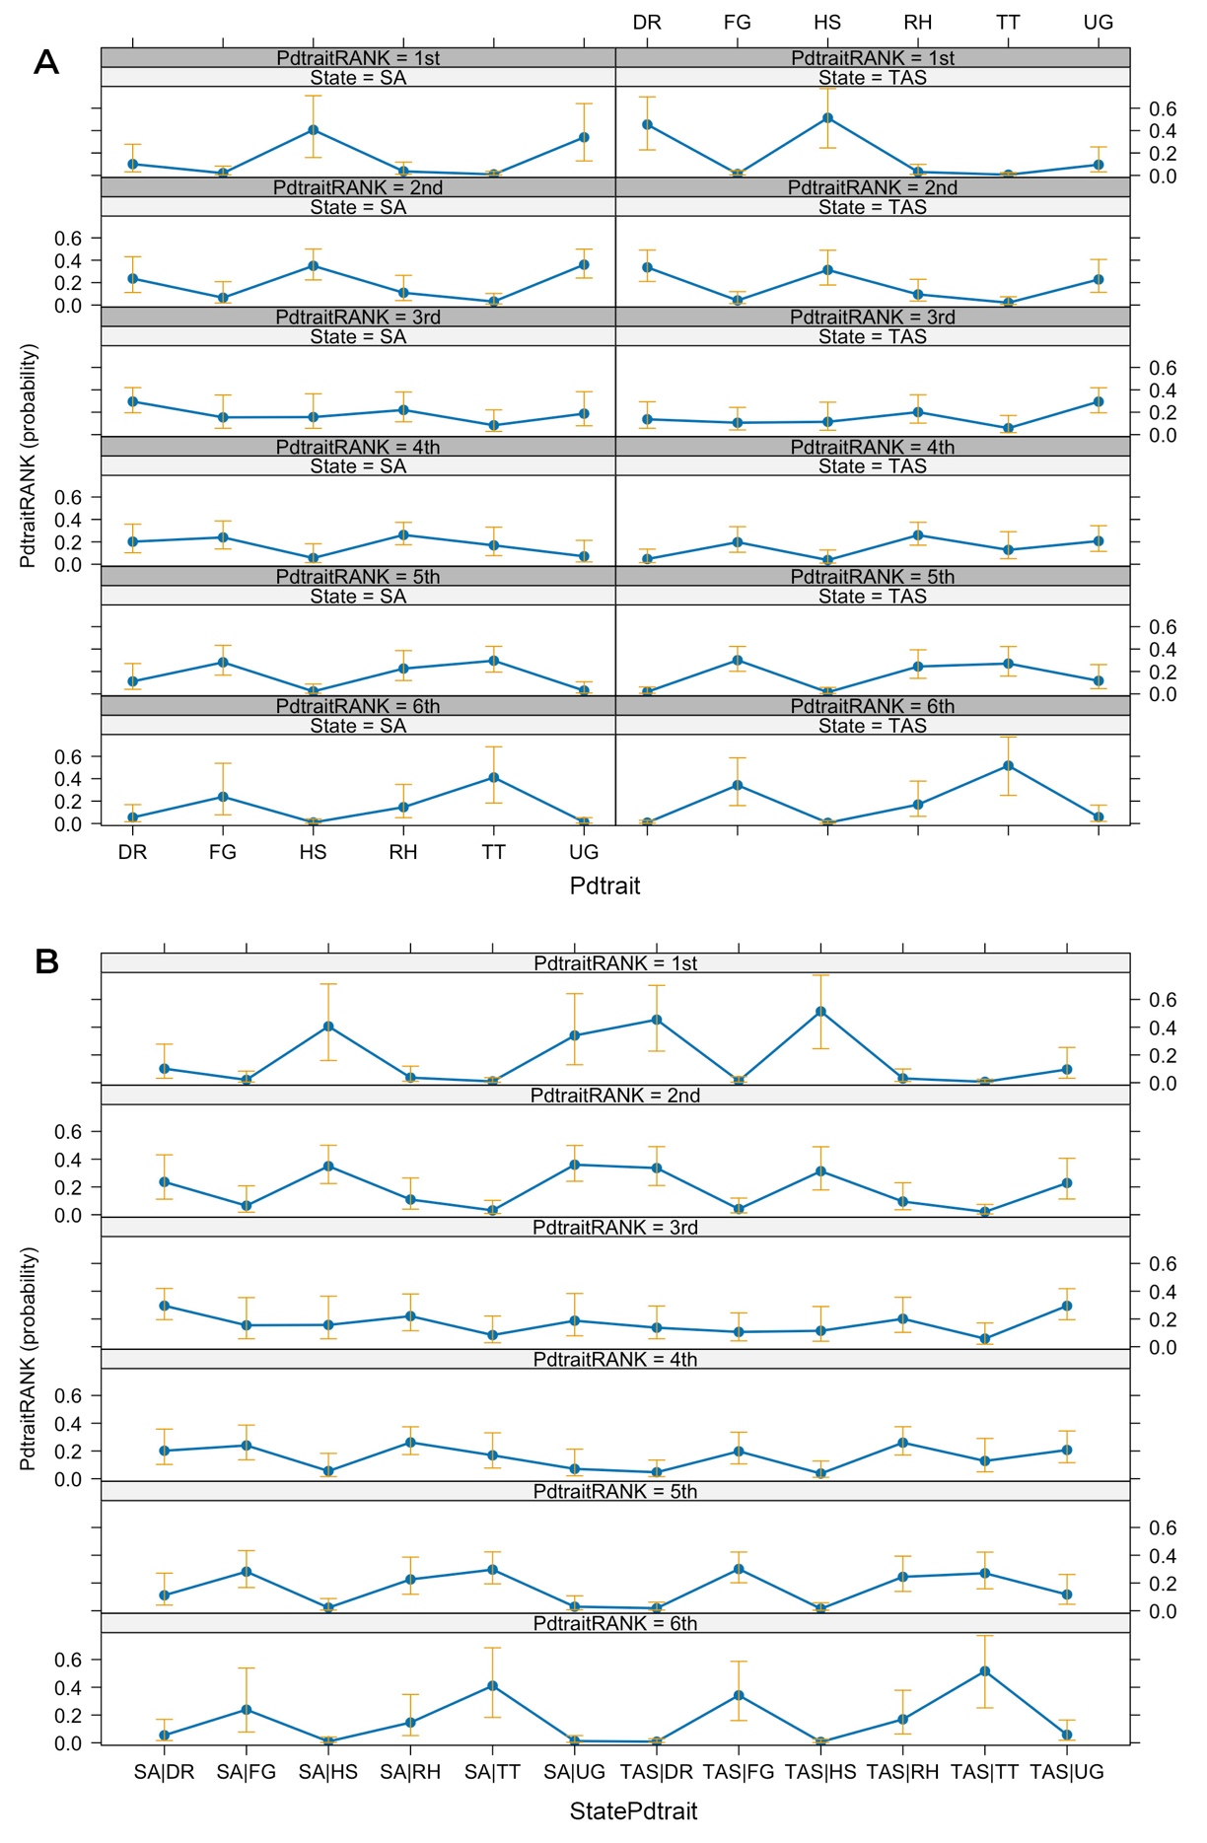

***Supplementary Figure 2***: Identical effects (probabilities) for the Pacific oyster production traits proportional odds logit models **A** without and **B** with concatenated interaction terms during the model fitting.

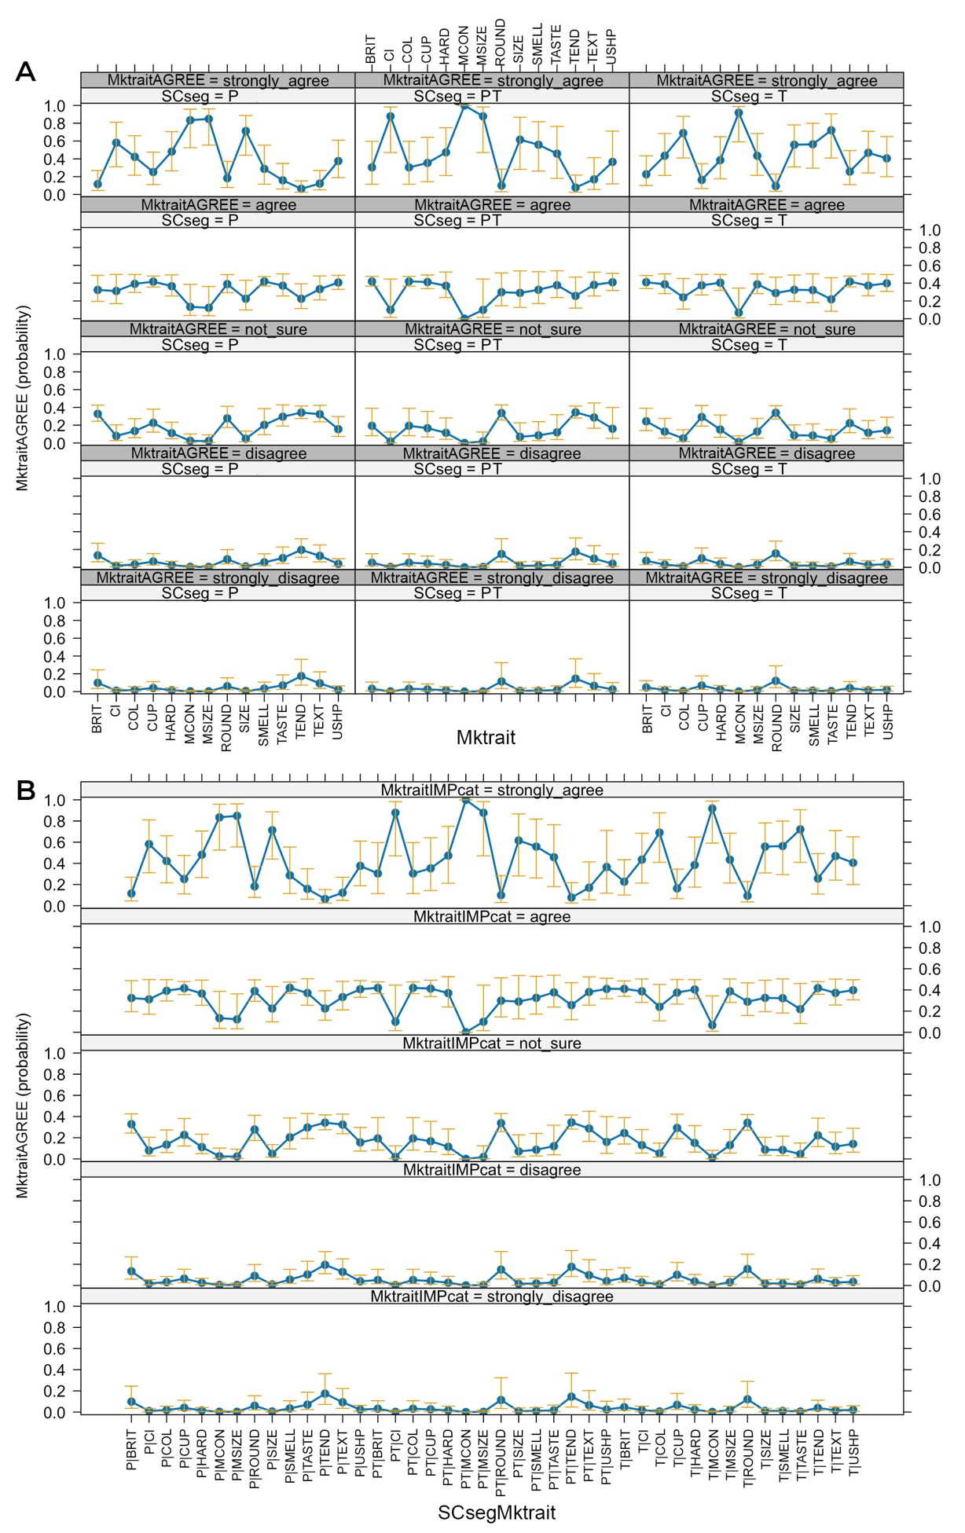

***Supplementary Figure 3:*** Identical effects (probabilities) for the Pacific oyster market traits proportional odds logit models **A** without and **B** with concatenated interaction terms during the model fitting.